UFO Photographs Slideshow

NAVIGATION MENU Photo 11 of 176 | FIRST | PREVIOUS | NEXT | LAST

Southern mountains of Taiwan
September, 2003
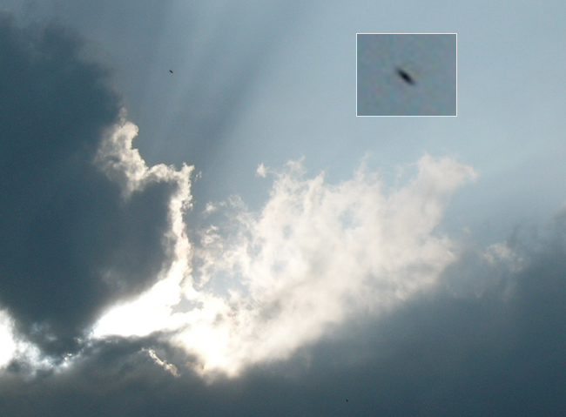
description:
"Cool picture of a bull in the clouds... The "ufo" is above the horns... I know, bull--it! But hey, this is what I've got. Shot in the mountains of central Taiwan in September."
- Brian Thompson, Taiwan
Source: Brian Thompson, Taiwan
Original source webpage / article

FAIR USE NOTICE: This page contains copyrighted material the use of which has not been specifically authorized by the copyright owner. This website distributes this material without profit to those who have expressed a prior interest in receiving the included information for research and educational purposes. We believe this constitutes a fair use of any such copyrighted material as provided for in 17 U.S.C § 107.

