UFO Photographs home | UFO Evidence home
UFO Photographs Slideshow

NAVIGATION MENU Photo 9 of 176 | FIRST | PREVIOUS | NEXT | LAST

Southeast Vermont, USA
December 2003
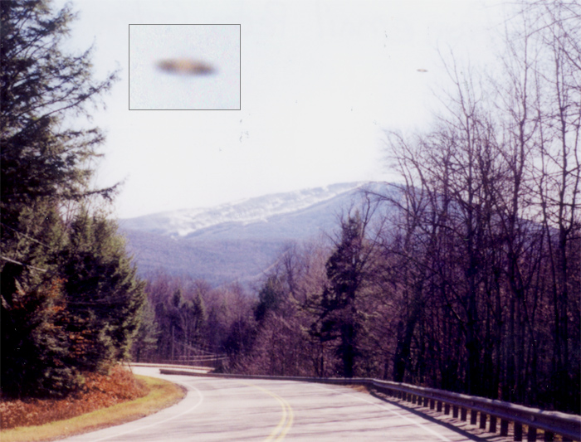
description:
Sighting Report:
Duration of sighting: 30 seconds
No. of Objects: Single
No. of Witnesses: 1
Full Description & Details: I'm a amatuer photographer from Connecticut. One weekend I decided to drive up to Vermont for a day of picture taking. I was very excited because I heard that snow had just recently fell up in the mountains so I was hoping to get some good shots.
I finally got up to Vermont and just started to drive around aimlessly, hoping to find some good photo ops. Mid-afternoon(about 2-3 pm) I saw this great shot of some mountain with snow blowing all over the place on top of it. That day had about 20mph winds with higher gusts, as you can see in the picture. I parked the car on the side of the road, and stepped out, kneeled down and started to set up my camera to take the picture.
As I was setting up my camera, something caught my attention out of the corner of my eye. It moved rather slowly, sort of like gliding, but not. It's very hard to explain because I have nothing to compare it to, it wasn't like anything I've seen before. It moved from the left to right in the picture(sorry, but I have no idea what the cardinal directions for that would be). The object looked as if it was having a little bit of trouble flying into the wind. After recovering from the awe in seeing this, I quickly took a picture. RIght after I took the picture it looked like the object stayed in the same sport for a second, and then it QUICKLY jolted all the way to right out of my view.
I have no idea what this object could have been, and now after viewing this site, I believe it may in fact have been a UFO. I hope this picture interests you as much as it intrests me.
Personal Background: Student(I rather not say which school)
Reported Sighting? No
Location: Connecticut, US
Source: Original photograph submitted to UFOEvidence.org
Original source webpage / article

FAIR USE NOTICE: This page contains copyrighted material the use of which has not been specifically authorized by the copyright owner. This website distributes this material without profit to those who have expressed a prior interest in receiving the included information for research and educational purposes. We believe this constitutes a fair use of any such copyrighted material as provided for in 17 U.S.C § 107.

