Zanesville, Ohio, USA
November 13, 1966
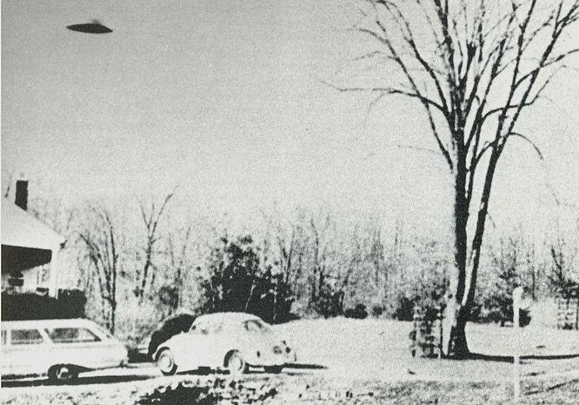
description:
Photographed by barber Ralph Ditter at his house in Roseville, a suburb of Zanesville, Ohio, in 1966. For years, Ditter exhibited this and another UFO picture taken at the same time in his barber shop. The Condon Committee examined both exhaustively, and concluded they were faked. Ditter failed to respond to requests for "clarification" of the differences between his account of the sighting and the apparent facts.
Source: UFO: The Complete Sightings, Peter Brookesmith
Original source webpage / article
Zanesville, Ohio, USA
November 13, 1966
description:
Photographed by barber Ralph Ditter at his house in Roseville, a suburb of Zanesville, Ohio, in 1966. For years, Ditter exhibited this and another UFO picture taken at the same time in his barber shop. The Condon Committee examined both exhaustively, and concluded they were faked. Ditter failed to respond to requests for "clarification" of the differences between his account of the sighting and the apparent facts.
Source: UFO: The Complete Sightings, Peter Brookesmith
Original source webpage / article

