Yukon, Oklahoma
September 30, 2003
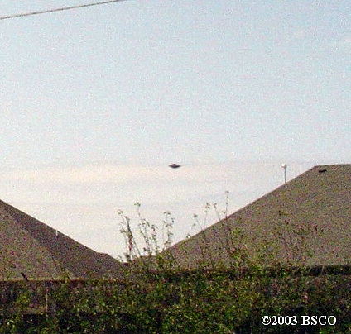
description:
Yukon, Oklahoma
Date: September 30, 2003
Time: 11:45 to 12:30 p.m.
Hi Brian
I recently was out in my back yard with a cup of coffee, and noticed something moving then stopped and hovered for about 30 seconds, so I went back in and grabbed our Sony cybershot digital cam and got a picture of it (lower right) UFO? My wife thinks it's a plane but I told her you should have seen it's movement, It flew off really FAST and was out of sight!
I was home from work this last Tuesday , 9-30-03, the time was about 11:45 to 12:30 p.m., not quite sure.
When I first noticed it, it was just hovering and slowly moving sideways a bit, just west of our house, maybe about 5-8 miles,and I would say somewhere between 2000 to 5000 ft ?? Not sure, when I rushed back outside with my cam, it flew off after 10 or so seconds, in a north, northeast direction ( there is also a small airport in that direction too) VERY high velocity also, in a few seconds it was gone!
This is the second time I have captured something strange on film, the other time, I caught on film what looked like a B1b bomber at high altitude. but I never saved it though. If I would have thought of it at the time, I would have put the cam on record, it takes short 30 sec videos, oh well.
Thank you to the witness for allowing me to post the report and pictures.
Brian Vike, Director
HBCC UFO Research
Canadian Toll Free UFO Hotline 1 866 262 1989 - Free call.
Home - Phone/Fax 1 250 845 2189
HBCC UFO Forum Board
http://216.147.50.102/HBCC-UFO/index.php
email: hbccufo@telus.net
Website: http://www3.telus.net/public/wilbur8/hbcc_ufo_research.htm
Source: HBCC UFO Research
Original source webpage / article

FAIR USE NOTICE: This page contains copyrighted material the use of which has not been specifically authorized by the copyright owner. This website distributes this material without profit to those who have expressed a prior interest in receiving the included information for research and educational purposes. We believe this constitutes a fair use of any such copyrighted material as provided for in 17 U.S.C § 107.

