Wyborg, Denmark
November 17, 1974
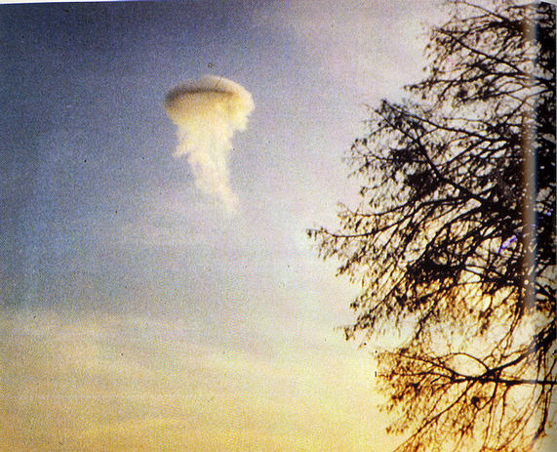
description:
UFO above Wyborg, Denmark, 1974, taken by H. Lauersen. This incident was investigated by Maj. Hans Petersen of the Danish Air Force. The vaporizing effect is explained by scientists as being the result of the surface of the UFO being cooler than -180 degrees Celcius. Because of that, the surrounding air becomes liquid and flows toward the Earth, which gives the object its jellyfish-like appearance.
Source: UFOs: The Secret History, Michael Hesemann
Original source webpage / article

