Woonsocket, Rhode Island, USA
June 16, 1967
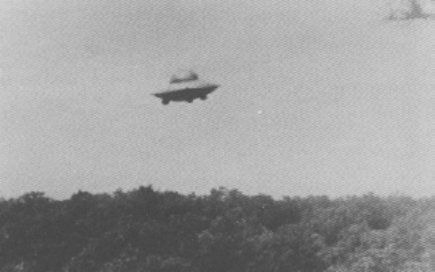
description:
Source:
Original source webpage / article

