Washington, D.C., USA
1952
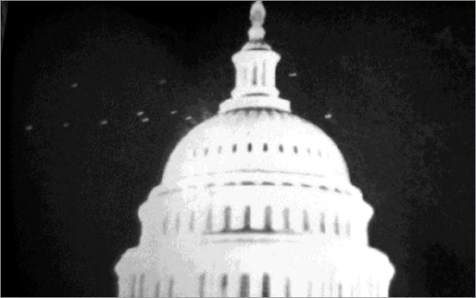
description:
Source:
Original source webpage / article

