Ward, Colorado, USA
April, 1929
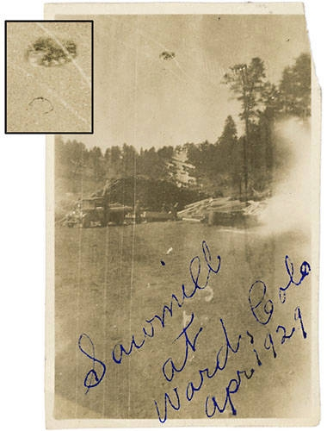
description:
Ward, CO. April, 1929
Hetty Pline
INCIDENT AT THE WARD SAWMILL
This photo was taken by my father Edward Pline at the sawmill in Ward where we lived at the time, I think it was 1929. I was about six years old then. My father was there to photograph the sawmill for some reason or another, and as he was taking the photo, he described a "terrible thunderous bellow," and a large round thing as big as a very large boulder that moved through the air above them.
You can see it in the picture. None of the sawmill workers saw the thing in the photo, but they all heard the sound and felt the ground shudder. Later in my life I tried researching the incident at the County Historical Society, but I did not find any references to it. My father passed on a few years after the incident, and I have not found any surving sawmill workers from that time. Perhaps you have more information about this incident.
Best wishes, Hetty Pline
Source: El Disco

