Vancouver, BC, Canada
1937
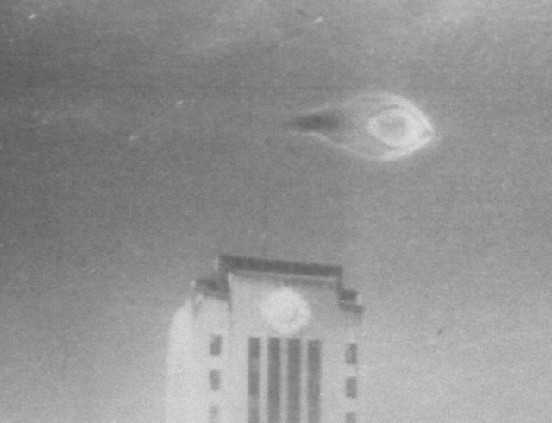
description:
Leonard Lamoureux, age 21 was on leave from the Army when he visited Vancouver City Hall to view and photograph the Christmas light display. Along with him was his brother Wilfred.
The two were suddenly astounded to see a "bright bright blue light" drop straight down from the sky. It became larger as it did so and they were able to observe the source of the light as an object that Leonard described as "two saucers" open ends facing each other, glowing bright blue. The object then moved "dead straight" horizontally across the sky. When it just appeared to clear the flagpole on the roof of the City Hall it came to an almost dead stop and Leonard clicked the shutter on the camera. The object then shot straight back up into the sky. "They never seen anything fly so fast!" This scared them to death and they ran from the scene. The object made no sound.
Leonard's daughter, Debra DeCamillis who still lives in the Vancouver Lower Mainland area related this account to us. She remarked how vivid and excited her father sounded each time he described the sighting. Leonard Lamoureux passed away in 1992 and his brother Wilfred in 1955. Misfortune has it that the negative is no longer around as some UFO researchers have suggested that this image is nothing but a watermark defect that appeared during the development of the print. Debra has this to add regarding this assertion: "I know for fact there was no bubbles on the film, or watermarks because I was facinated by negatives as a child and saw that negative many many times. On the rest of the pictures there was nothing but pictures of lights, so I know it had no bubbles or watermarks on it."
Deborah provided the following additional details: "The camera was on a tri-pod of sorts because Dad was trying to take sequential shots of the courthouse to capture all the lights. But he was not using a timed exposure, his camera was not sophisticated enough. He did say that he could actually see the bubble or tail as he called it that the object was encapsulated in."
Source: UFO*BC
Original source webpage / article

