United States
1964
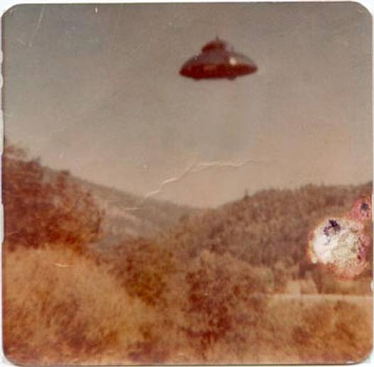
description:
Unique family heirloom
This entry has few details except an unknown location in the US, a date of June 10, 1964 and: "I did not take this pic. It was discovered by my sister in an old family bible. It was taken by her husband's father but he had no more info than that." The image is exactly as we received it, same size and all, with no modifications whatsoever. Based on the size and shape of the paper, this appears to be consistent with an old photo, complete with wrinkles, water stains, and what looks like a cigarette burn. I posted this image on an online UFO club and garnered several responses, including:
"I must agree the photo looks to be genuine.. I wonder if anyone has thought of submitting the photo for analysis to Mufon or CUFO's...The ship in the photo bears a great deal of resemblance to the so called Beam Ships photographed by Billy Mier.. I can think of no reason someone would go to so much trouble as to fake a photograph then hide it in a family bible for years.. Especially back in the days when faking a photo like this was a real technical achievement, requiring the talents of a model builder and a highly skilled [amateur] or professional photographer.. Just possibly this is one of the better photos to be taken of a real UFO.. Will be interested to see any follow ups.. "
- JERRY (64/M/ROSEBURG, OREGON)
Source: ufodatabase.com
Original source webpage / article

