Tiensten, Hopeh Province, China
1942
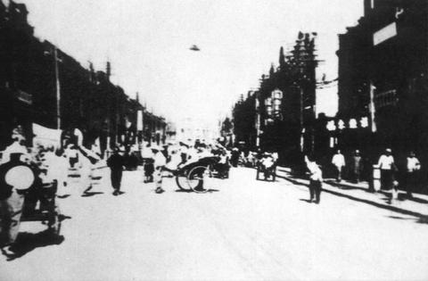
description:
Young Japanese student Masujiro Kiryu, going through his fathers scrapbook of photographs fron the China Campaign, just before World War II, discovered a strange cone-shaped object in the sky above a Tsientsien Street. A number of people in the street are looking up and two are pointing up at the object. A sidewalk photographer snappped a picutre of the strange machine and his father bought it from the street vendor for a souvenir of the place.
Additional info about this photograph from UFOArtwork.com:
There seems to be some confusion over this photo. One site states it was taken in the city of Tienjin, China in 1911 by a Japanese journalist. Source. Another site says it was taken in Tiensten, Hopeh Province, China in 1942 . Source. I recently received this information from Alain Stauffer, Geneva : Chinese ufologist Shi Bo: "La Chine et les extraterrestres" (in French, since Shi Bo lives in Paris). He states in his book (my translation): "In 1942, an American man on duty was walking in the street of a town [not specified] in the north of China. He suddenly saw a black hat silently flying above the street. He immediately grabed his camera and took this first picture of a UFO in China. This American citizen wished to visit China very soon in order to trace the witnesses of this event." (This commentary has been written in 1982 - the book was published in January 1983). Additional information comes from Wendelle Steven's "UFOs over Modern China" UFO Photo Archives. Young Japanese student Masujiro Kiryu, going through his fathers scrapbook of photographs fron the China Campaign, just before World War II, discovered a strange cone-shaped object in the sky above a Tsientsien Street. A number of people in the street are looking up and two are pointing up at the object. A sidewalk photographer snappped a picutre of the strange machine and his father bought it from the street vendor for a souvenir of the place.
Source: Wendelle Stevens, reposted on UFOArtwork.com
Original source webpage / article

