Tepoztlan, Mexico
June 7, 1992, ca. 6:30 a.m.
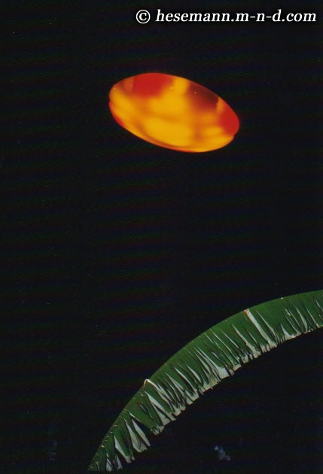
description:
Carlos Diaz photo of 7 June 1992, ca. 6.30 a.m.
In-depth case investigation by Michael Hesemann:
Ships of Light: The Carlos Diaz Experience
http://hesemann.watchers.ca/shipsoflight.html
According to experts it is the best documented UFO contact case in the history of the phenomenon. With certainty it is the most carefully investigated extraterrestrial encounter.
THE CASE
In the early hours of March 23, 1981 Carlos Diaz, a young photographer from Mexico City, drove into the Ajusco National Forest in the "zona vulcanica" south of the capital. A magazine had commissioned him to take pictures of a sunrise in the mountains, and for this he has chosen a well-known vantage point. He parked his car, waited for the sun to dawn. Suddenly he saw an orange light shining up from the slope in front of him. First he thought it was a fire, but then he recognized a yellow-orange dome. It was a UFO! Immediately he grabbed his camera, shot a first photo, when the disc was just facing him. In this moment, the engine of his car went off. Diaz shot his second picture before he jumped out of the car, just to see and photograph how the disc was shooting off with high speed.
When he got the photos back from the lab the same afternoon, Diaz knew that he did not dream. This experience never let him off. As often as possible he returned to the Ajusco National Park. But only two and a half month later, on a rainy day, he saw the orange glow again, this time coming from the top of a hill. He parked his car, climbed up the muddy volcanic rocks, when he eventually saw the object hovering in front of him. Deeply moved by what he saw, he suddenly felt someone touching his shoulder. In the same moment he fainted. When he recovered, the rain had stopped and the object had disappeared. Completely bewildered, he climbed down the hill, back to his car…
In the following month, Diaz started to remember step by step what had happened to him during that "missing time". More than that, a friendly contact developed between him and the pilots of these mysterious "Ships of Light". Carlos decided to move into the valley of Tepoztlan, 40 miles south of Mexico City, where these objects were seen since man can remember. He was able to take several more spectacular photos. And he had further encounters which taught him why these beings come to this planet and how worried they are about all life, all living beings on Earth.
Ten years later, the sun was darkened over Mexico. During the eclipse of July 11, 1991 thousands of witnesses saw strange craft in the skies. The prominent TV anchorman Jaime Maussan investigated the sightings, commissioned a scientific analysis of UFO footage. Carlos felt that the moment has come to go public with his experience. He contacted Maussan who was deeply impressed by the quality of his photos. More than that, he tried an experiment. He gave Carlos, who could not afford one, a video camera. He was not disappointed. Only three days later, Carlos presented him the first film. Three more followed within the next five month. They all show the same "Ship of Light" which was also on his photos, in breathtaking maneuvers over the valley of Tepoztlan. One time it came so low that it filled the whole frame of the camera.
CONCLUSION
Thousands of eyewitnesses, radar observations, photos and films which stunned the experts and a contactee with a high degree of personal integrity – the Carlos Diaz experience can indeed be called one of the most important UFO contact cases in the history of the phenomenon. For this reason, the researchers investigated it as careful as possible – and waited seven years, until every aspect was put under scrutiny, before they published it. Never before so many international experts were consulted in the investigation of a UFO contact case. All researchers who met him were impressed by the honesty and sincerity of Carlos Diaz, an impression shared by his neighbours, his family, the mayor of Tepoztlan. Nobody in Tepoztlan ever questioned his experience since every second of the "Tepoztecos" has seen these objects, too.
The case will be one of the most important for the UFO research of the 21st century, because it goes far beyond sightings, contact and evidence. The Carlos Diaz experience indicates a direct connection to the ancient civilization of the Maya, one of the oldest and most mysterious cultures on the American continent. It gives us explanations about the propulsion and navigation of extraterrestrial craft. But in its center stands a message, which concerns all of us, an urgent call to save and protect life on Earth, which is endangered by us, to inherit our children a living planet. When we eventually learn to love and respect life, Diaz is convinced, a contact "with them" will be inevitable.
Source: Michael Hesemann
Original source webpage / article

