UFO Photographs home | UFO Evidence home
UFO Photographs Slideshow

NAVIGATION MENU Photo 3 of 176 | FIRST | PREVIOUS | NEXT | LAST

Tasmania, Australia
January 4, 2004
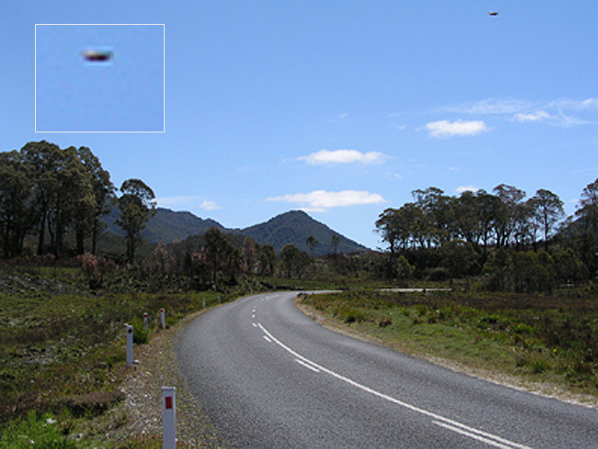
description:
Camera: C5050 Olympus Camedia (5 Megapixel Camera)
Comments from the photographer:
"I took a series of photos "panoramic" from south west to north west on the A10 Highway& somewhere between the Franklin & Alma Rivers.
My wife and myself recently spent 8 days in Tasmania, we had a wedding to attend on the 4th of January and decided to get to Tassie a few days earlier and spend a few days there after the wedding. On the 3rd of January we travelled from Hobart to our destination for that day "Cradle Mountain", being a bit of a mad photographer and with a digital camera I tend to take a lot of photos.
I would guesstimate the time being around 2pm. That night I downloaded the photos onto my Notebook computer at our accommodation at the Highlander at Cradle Mountain, it was not until the next day when we had arrived at Hawley Beach "location of the Wedding" I was showing some friends over a couple of pre wedding drinks some photos that I had taken to date on our adventure the object was spotted by my
friend Jason. On my return to melbourne I sent the photo of to a couple of UFO sites I had found on the www you being on of them "the other sent me a dirty reply for wasting their time".
(Info from Australian UFO Research Network http://www.hypermax.net.au/~auforn/UFOTasmania.html )
More information and brief analysis can by found by Australian UFO Researcher Barry Taylor at:
http://www.theozfactor.cjb.net/oz_1.htm
Source: Rod Beveridge / Australian UFO Research Network
Original source webpage / article

