Stonehenge, England, UK
1990
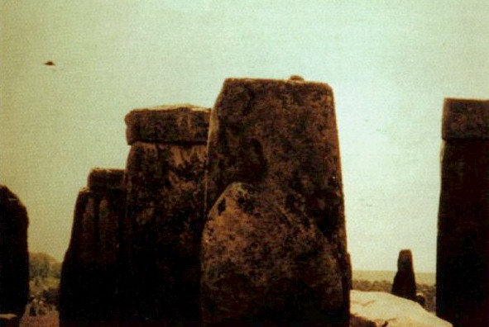
description:
Source:
Original source webpage / article

