St. Lorenzen/Styria, Austria
23 May 1971, 12.30 p.m.
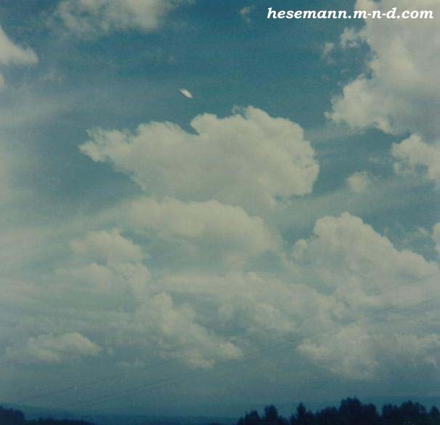
description:
23 May 1971, 12.30 p.m.
St. Lorenzen/Styria, Austria:
During his vacations in Styria, the Munich musician Rudi Nagora and his wife explored the area around St. Lorenzen. Looking for a nice landscape, they were driving around with their car to park it somewhere and go for a walk. About noon Nagora stopped at the edge of a field, in a parking bay, left the car to inspect the area, when his wife waited inside the car. In this moment his attention was drawn by a whizzling sound coming from the sky above. He looked up and saw a shining, silver disc, moving in front of the clouds in a kind of zig-zag pattern. Immediately he ran back to the car, telling his wife and grabbing his Agfa-Click camera. He put it up, tried to catch the disc and snapped one photo after the other, twelve in total, until the film was full. In this very moment the disc came down for a moment, approached the witness, before it was shooting straight up and disappeared through a hole in the clouds. The sighting lasted for about five minutes.
Later, Munich UFO researcher Engineer Adolf Geigenthaler learned about the case and started an investigation. Nagoras photos were considered authentic by many competent researcherst including GSW, Col. Colman VonKeviczky, Illobrand von Ludwiger, Adolf Schneider and others who carefully analysed them. They belong to the best UFO photos ever taken. In two instances (photo 3-7, photo 8-10) a clear, logical course of the object can be observed what rules out the possibility of a frisbee or hub cap thrown into the air. Furthermore, in one of the photos the object enters a cloud. It obviouly moved in an alitude of 3000-3600 feet!
(c) 2000 by Rudi Nagora. All rights reserved. High quality prints of this series (8x8 inches or 20x20 centimeters) can be ordered for only $5 each/$ 60,-- the series directly from the witness, whom I asked to make them available for the UFO research community: Rudi Nagora, Robert Koch Str.7, D-82008 Unterhaching/Germany
Source: Michael Hesemann
Original source webpage / article

