NAVIGATION MENU Photo 19 of 176 | FIRST | PREVIOUS | NEXT | LAST

Spokane, Washington
July 17, 2002
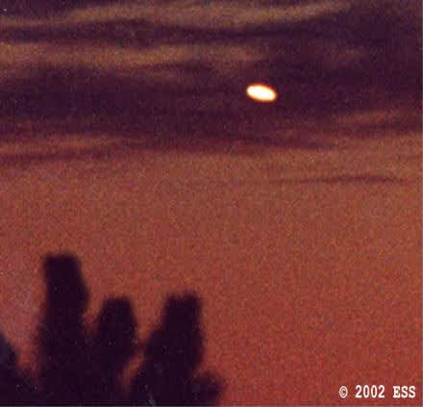
description:
Letter submitted with photographs to Jeff Rense:
Dear Mr. Rense,
Recently, you had a guest, Mr. George Filer, who discussed some of the photos that I have been taking of anomalous night lights and craft in the Spokane, Washington area for about five months now.
As you may well remember, Mr. Filer mentioned that a few of my photos had been analyzed by Jeff Sainio, photo analyst for MUFON. Mr. Sainio's preliminary analysis is that some of these photos do indeed show flight patterns and lighting changes not usually present with traditional or known aircraft. I can tell you that in 40 some years of watching the night skies and aircraft, I have never before seen what I have been observing since February.
I do not presume to know what these lights and craft are, or where they come from. They may very well be of terrestrial origin, but then again, they may not. I have been in contact with a number of organizations in an attempt to get someone with credentials and expertise to investigate this ongoing flap. Although there are a number of very talented and helpful individuals who have offered me assistance, none are local, and I am no closer to figuring out what is going on than I was five months ago. What I can tell you with some degree of certainty is that our Government is aware of this phenomena.
For the first month or two of the sightings, I observed several dramatic interactions between what appeared to be military aircraft, and the lighted objects. The aircraft would fly toward the lights, and the lights would move away in response. I didn't get the sense that the aircraft were attempting to engage the lights in a military action, as much as attempting to "harass" the lights into leaving. Much as you would try to "shoo" a dog off your property.
Lately, all I see is an occasional high altitude surveillance aircraft monitoring the area. Anyway, I have decided to send you a few of my photos, and give you permission to post them on your web site. These photos were taken using a small telescope and a 35mm camera. I am a novice photographer. All I ask is that you share with me any feedback or comments that you receive. I will be happy to answer any questions that you may have. The attached photo is of a boomerang shaped object flying by a radio tower on nearby Tower Mountain.
Source: Rense.com
Original source webpage / article

FAIR USE NOTICE: This page contains copyrighted material the use of which has not been specifically authorized by the copyright owner. This website distributes this material without profit to those who have expressed a prior interest in receiving the included information for research and educational purposes. We believe this constitutes a fair use of any such copyrighted material as provided for in 17 U.S.C § 107.

