Sidney, Australia
1988
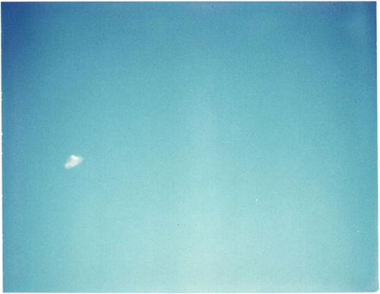
description:
This is the message emailed to "El Disco" (a web UFO picture collection) regarding the picture:
"Dear Sir/Madam,
After seeing the attached picture (from your sight) I might as well tell you a little story, I'm not a loony, I saw this same thing 2 summers ago when I was in Oz. It's about 2:30pm, very sunny, clear sky , me and my flat-mate in Sydney were out laze'in in the sun when this same looking thing flew out from behind the only cloud in sight. I was wearing ray-bans for the sun so my view was darkened to a deep purple, then suddenly a flash just like on a camera, only it was miles up... I watched for about 2 minutes , then it made an enormous 'Z' path in the sky. (I know this sounds all too common/corny), I couldn't believe how fast it moved, faster than I could follow in the sky with my eye's & shades !!!. Then after watching it move (mile's up) around in a circle that lasted for about another 3 min, I lost it. All this time it has only been a bright light in the midday sun, taking my shades off to double check my eyes and to be sure I haven't been watching a chip in my ray-ban lenses for the last 10 min, I came to the conclusion it was only a satellite reflection and my imagination and my eyes being fouled by the bright sun. Then WOW I saw it flash the suns reflection and it sped across the sky at a massive speed then stopped dead, followed by a faint popping noise. At this point it was about 20 degrees up from me (I'm on a hill, for the breeze!)about 150ft up, it hovered about a cricket field away (guessing from the shadow it made on the surrounding field) and was about the size of my thumb nail. No description of the craft is needed as it is identical (99% sure) to the attached photo. It stayed there for 20 sec's approx.. then very slowly moved to about 2 o'clock from 12 o'clock of my view for another 10 sec's. Just as I blinked it started moving up and away from me, in the time it took my eyes to focus on it, it had almost disappeared straight up... As I said before I am not a loony and DID see this, I even have my flat-mate as a witness to verify he saw exactly the same thing. Hope this hasn't wasted your time, I tend to go on a bit.
Sincerely, Robin.S.Phillips"
Bagira@HKstar.com
Source: El Disco
Original source webpage / article

