Sicuani, Peru
December 6, 1968
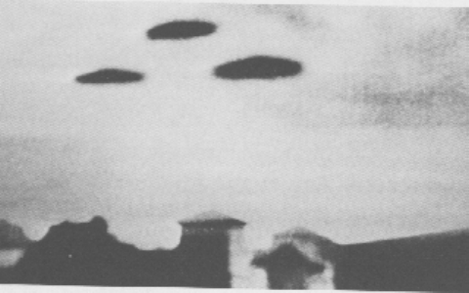
description:
Source:
Original source webpage / article

