NAVIGATION MENU Photo 145 of 176 | FIRST | PREVIOUS | NEXT | LAST

Sicily
1954
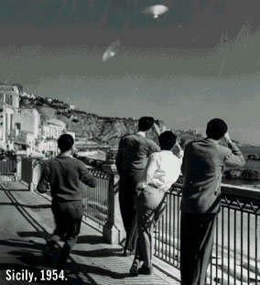
description:
Sicily:
These unidentified flying objects were seen in the sky over Sicily. Similar photos were reported to have been taken in other European countries. The authenticity of the images was checked by questioning the photographer, who said the objects were in the sky and remained still for several minutes. Numerous ground observers from different spots confirmed it.
Mainly because the observers seem to look in a directions where the objects are not, the photograph is generally considered a hoax.
Source: UFOs at Close Sight (Patrick Gross)
Original source webpage / article

FAIR USE NOTICE: This

