Seattle, Washington, USA
January, 1966
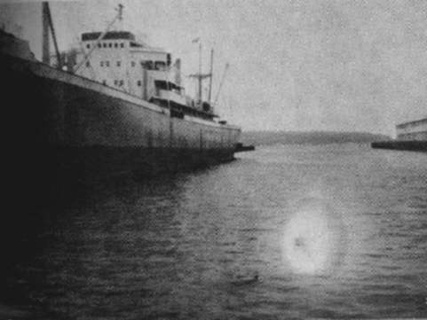
description:
UFOs at Close Sight (Patrick Gross)
Project Blue Book Files
SEATTLE, JANUARY 1966:
Project Blue Book team almost got its wish for "swimming UFO's" when this photo turned up. Taken by Jerry Ross ("I'm not a believer in flying saucers." he stressed) in Seattle in January, 1966, the photo baffled all the experts.
Source: UFOs at Close Sight (Patrick Gross)
Original source webpage / article

