NAVIGATION MENU Photo 129 of 176 | FIRST | P  REVIOUS | NEXT | LAST
  Northcliff, South Africa
  1963
  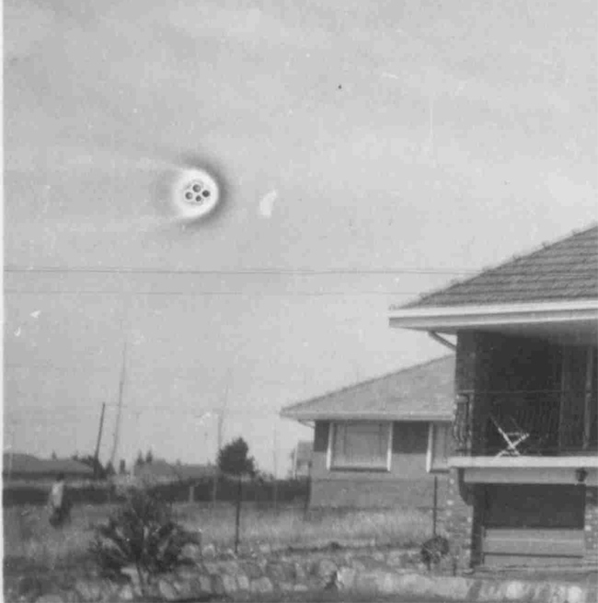
  description:
  From South Africa's UFO Resource:
  "Following is the description on the photograph above, from our source. We are patiently waiting 4 the photographer 2 make contact with our source's mother, so that we may establish the location. Click on the thumbnail 4 the larger image (1126 x 1163 pixels, 28kb, compressed).
  The photo was taken in South Africa. The person was an estate agent in 1963 (now 80jrs old) and took some photos of the houses she had for sale to be published in the news paper. It was a black and white small photo and she saw this mysterious "mark" on it but couldn't make it out but kept it anyway. She stayed in the same retirement village as my Mom and showed her the photo. My Mom immediately recognized the possibility that it could be an unidentified flying object and asked if she could borrow it to show me. Well, thanks to today's technology, I scanned it in and zoomed up and walla!
  Additional info received on Sunday 5 October 2003
  About the UFO photo, it was taken in the Nothcliff area also called "Eagles Nest" near El Corro JHB, not far from the Cresta Shopping Center, Blackheath/Randburg."
  Source: South Africa's UFO Resource
  Original source webpage / article

Saskatoon, Saskatchewan, Canada
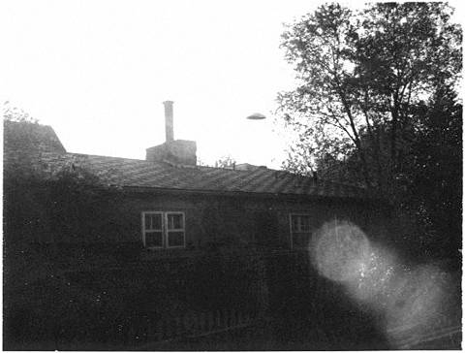
description:
Saskatoon, Saskatchewan. 1961
Gene Hurley
"...Gene past away some time ago, but his memory is still with us strong. He claimed to know these men. They are not men of God, he told us, but they are not men of evil. They're from Pledian. Somewhere nicer than this." D.H.
Source: El Disco
Original source webpage / article

