Saskatoon, Saskatchewan, Canada
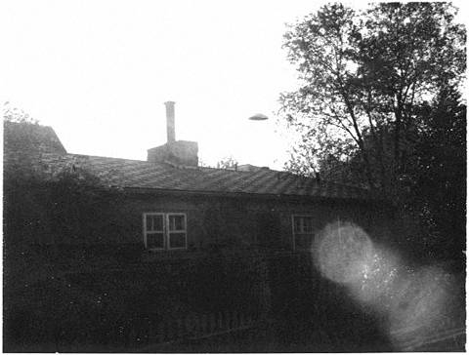
description:
Saskatoon, Saskatchewan. 1961
Gene Hurley
"...Gene past away some time ago, but his memory is still with us strong. He claimed to know these men. They are not men of God, he told us, but they are not men of evil. They're from Pledian. Somewhere nicer than this." D.H.
Source: El Disco
Original source webpage / article

