Santa Monica, California
February 1979
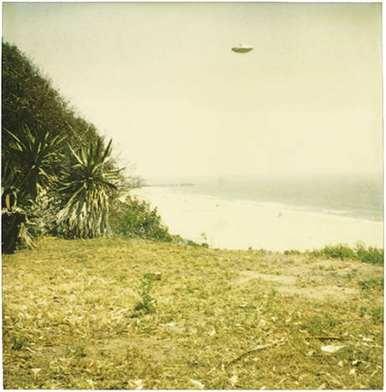
description:
Santa Monica, California. Feb 1979
Gigi Brobeck
"Dear Eldisco,
Attached is a polaroid I took back in Febuary, 1979 while I was out photographing humming birds along the cliffs above the Santa Monica beach. I hope this is helpful to you. My brother says it is the best evidence yet on the existence of ufos. If you need any more information you can phone me at [removed]. Please do not give out my phone number nor my email address. Thank you again." Gigi Brobeck
Source: El Disco
Original source webpage / article

