UFO Photographs home | UFO Evidence home
UFO Photographs Slideshow

NAVIGATION MENU Photo 1 of 176 |  |  | NEXT | LAST

Santa Monica, CA, USA
January 3, 2004
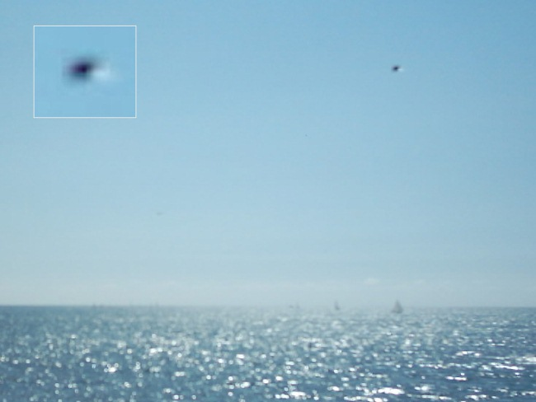
description:
Length of the yacht is 10 meter. You can see stopped supertanker at left side. UFO is stopped and staying above the yacht. (Despite of my cheap digital camera have only one slow speed shutter, I have clear UFO image. So, the UFO was stopped above the yacht at that time.)
Source: Original photograph submitted to UFOEvidence.org
Original source webpage / article

FAIR USE NOTICE: This page contains copyrighted material the use of which has not been specifically authorized by the copyright owner. This website distributes this material without profit to those who have expressed a prior interest in receiving the included information for research and educational purposes. We believe this constitutes a fair use of any such copyrighted material as provided for in 17 U.S.C § 107.

