Pacific Northwest, US
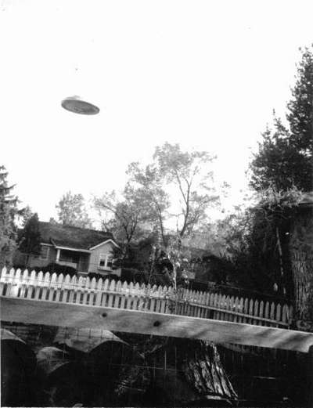
description:
Pacific Northwest, US.
Anonymous
"Thought you shuld all know about this. It's a UFO."
(El Disco)
Source: El Disco
Original

