Salem, Massachusetts, USA
July 16, 1952
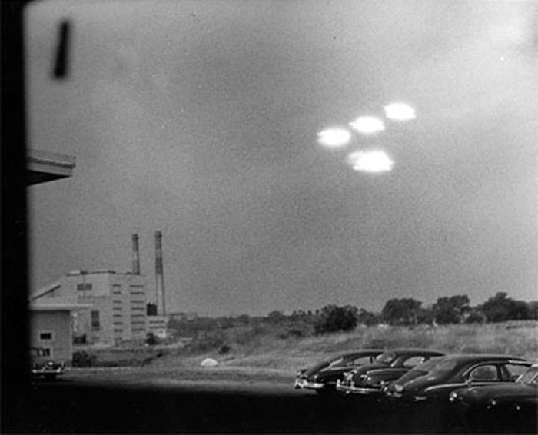
description:
Project Blue Book case 1501:
SALEM, JULY 16, 1952
The case occurred on July 16, 1952, at Salem in Massachusetts, USA.
At 09:35 A.M., the witness, Shell Alpert, took this picture of four roughly elliptical blobs of light in formation through the window of his photographic laboratory. Alpert was a Coast Guard seaman assigned to the base in nearby Salem, MA. This photo has appeared numerous times in the Salem (MA) Evening News.
The first analysis by US Air Force's Project Blue Book concluded it was "probably" a double exposure hoax.
A second analysis by Blue Book concluded that it was "probably" reflections of street lamps on a window.
Finally, the case was considered "unexplained" by Project Blue Book.
REFERENCES:
The photograph is at the NARA, the National Administration for Records and Archives, www.nara.gov Washington DC, where the complete declassified USAF Project Blue Book files are available to researchers in NARA's microfilm reading room. You can view the image in a better quality and read the corresponding Blue Book case documentation.
The reference for this picture at NARA is National Archives Record Group 341, Project Blue Book Case No. 1501.
This photograph has also been published in the book "Secrets of the Unknown, the UFOs," Time Life Books, ISBN 90-6182-993-3.

