Sadelegg, Switzerland
March 8, 1975
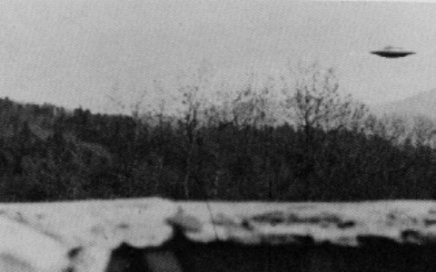
description:
Probably Billy Meier photo (?)
Source:
Original source webpage / article

