Saavedra, Argentina
1981
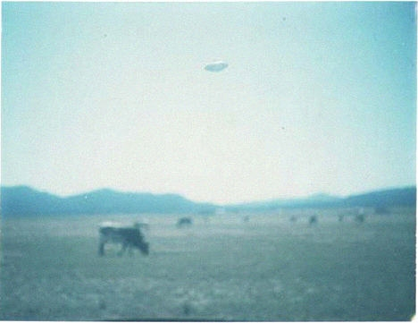
description:
Saavedra, Argentina, 1981
Leopoldo Diaz
[No further information]
Source: El Disco
Original

