NAVIGATION MENU Photo 171 of 176 | FIRST | PREVIOUS | NEXT | LAST

Russia
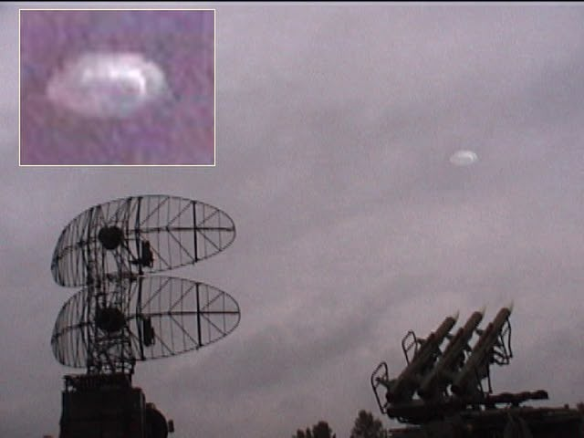
description:
Source:
Original source webpage / article

