Rosetta/Natal, South Africa
17 July 1956, ca. 4 p.m.
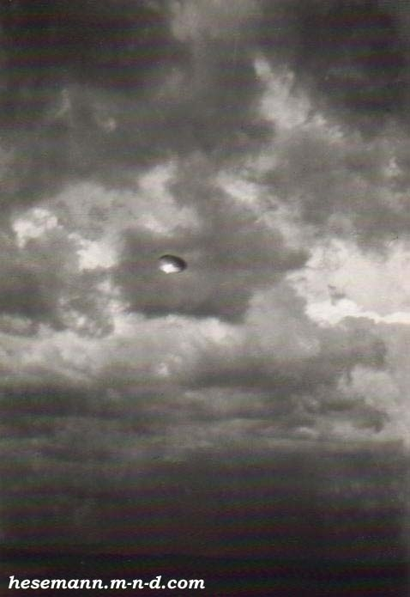
description:
The Drakensberg Photos
17 July 1956, ca. 4 p.m.,
Rosetta/Natal, South Africa
Dipl.-meteorologist Elizabeth Klarer caused an international controversy with her claim of a contact with Extraterrestrials. Her book "Beyond the Light Barrier", written more in the style of a romantic novel, caused a rather sceptical response, since Klarer claimed she became pregnant after her encounter with a tall, white-haired spaceship-pilot. Only in the Nineties, when cases of pregnancies after UFO abductions were given attention by serious researchers, the Klarer case received a more serious attention. Indeed Cynthia Hind, Africa´s most respected UFO researcher and MUFON representative, managed to locate and interview several eyewitnesses of Klarer´s contacts. Furthermore, Klarer was a well-respected member of the South African society. Her husband was a major of the South African Airforce, Elizabeth herself worked for the Airforce Intelligence. Her photo series of an "extraterrestrial spaceship" (as she called it) was taken in the presence of two witnesses whom she wanted to show the site of her first contact. With them she drove through the Zulu-Land, the foothills of the mighty Drakens-Mountains, when she noticed a flash of light between the mighty thunderstorm clouds. Immediately she stopped, left the car together with her companions, in her hand theBrownie Box Camera she had brought with her. A moment later she recognized the metallic disc in the dark-clouded sky, obviously slowly approaching. Immediately, like in a reflex action, Elizabeth shot seven photos before the disc suddenly shot away. In the same moment a thunderstorm started, a shower of hail went over the field. Elizabeth Klarer confirmed the authenticity of her photos in an notarized affidavit. She stood behind her story until she died in February 1994, in the age of 83 years.
Four of the seven UFO photos taken by Elizabeth Klarer on July 17, 1956 - enlargements. Note that the cloud formations did not change remarkably on the last two photos, indicating that they were shot within seconds. The disc seems to follow a clean curve, ruling out the possibility of a frisbee or a hub cap thrown into the air.
Source: Michael Hesemann
Original source webpage / article

