Rome, Italy
July 18, 1997
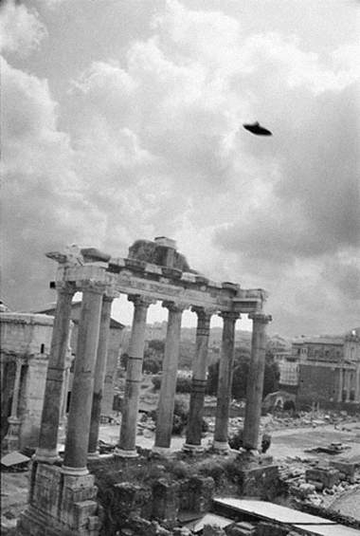
description:
Rome, Italy. July 18, 1997. 10:00 am
Drew Wright
I had a terrible hangover from all the cheap red wine I had imbibed the night before, my first night in Italy. As I saw the "thing," some local boys were saying "il disco," and pointing skyward. I snapped this quick shot before it vanished. I never made it to the Sistine Chapel.
-Drew Wright
(El Disco)
Source: El Disco
Original source webpage / article

