Rio de Janeiro, Brazil
Summer 1956
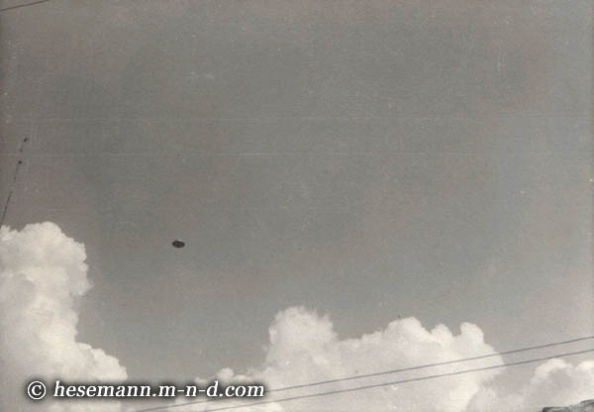
description:
Summer 1956, Rio de Janeiro/Brazil
A. Stizak photographed this metallic disc crossing the clear, blue sky. Note the three "white spots" on the underside in the enlargement. An analysis by ICUFON-director Col. ret. Colman VonKeviczky confirmed the authenticity of this early Brazilian UFO photo.
Source: Michael Hesemann
Original source webpage / article

