Rio de Janeiro, Brazil
March 10, 1989
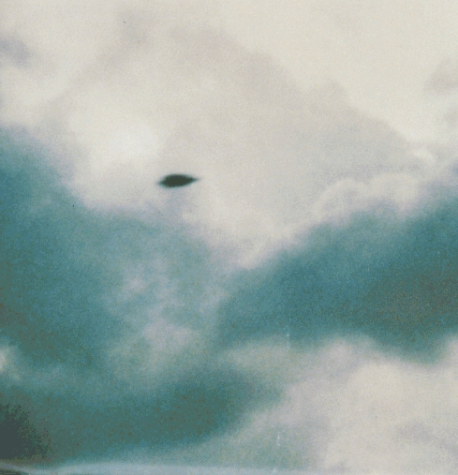
description:
Source:
Origin

