Puerto Rico
May 9, 1988
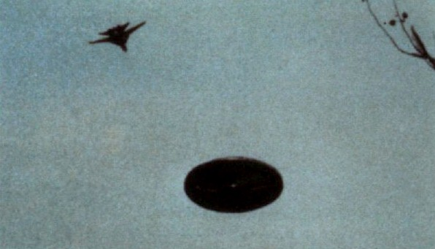
description:
Source:
Original source webpage / article

