Puebla, Mexico
December 8, 1992
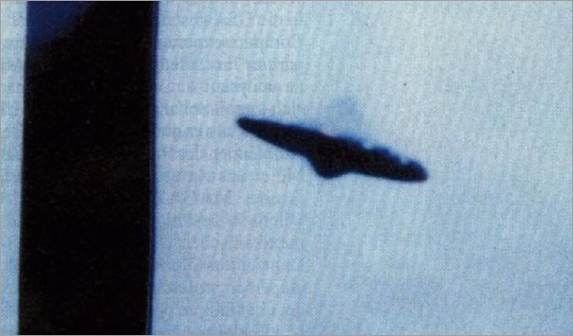
description:
Source:
Orig

