NAVIGATION MENU Photo 120 of 175 | FIRST | PREVIOUS | NEXT | LAST

Yungay, Peru
March 22, 1967
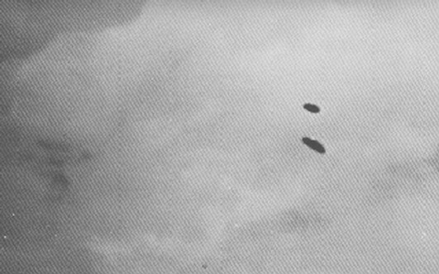
description:
Source:
Original source webpage / article

