Passoria, New Jersey, USA
July 31, 1952
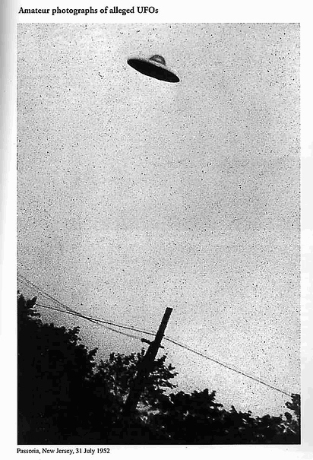
description:
Source:
Original source webpage / article

