Parana, Brazil
January 1, 1990
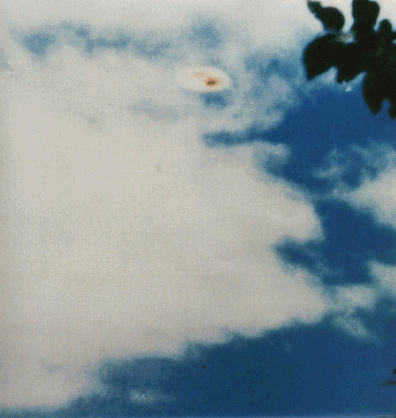
description:
Source:
Original source webpage / article

