Parana, Argentina
September 6, 1970
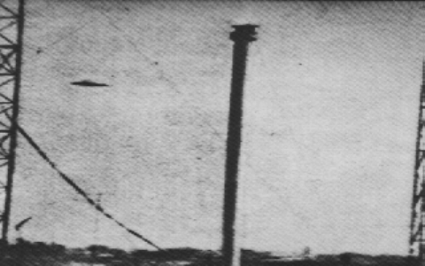
description:
Source:
Original source webpage / article

