Pahrump, Nevada
1978
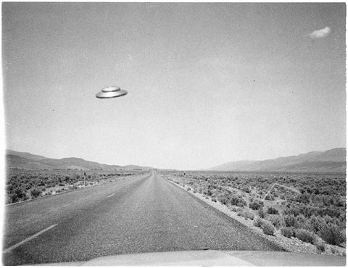
description:
Pahrump, Nevada. 1978
Jared Mathews
"You can have it. This came to Pahrump before Mars Attacks and even Art Bell, but neither of them care about it, so at least you can post it and somebody might know something. I was on my way back from a cathouse (no kidding). It was pretty early, around Christmas. Thought I was done for for a second, cause this thing was checking me out for sure. I slowed down to about 5 miles an hour and managed to take the picture before it took off over my truck and back behind me. I got out of the truck then but couldn't see it no more. Never heard a sound either. Do you have any more of this UFO? I searched your site, but can't find any."
Jared Mathews
Source: El Disco
Original source webpage / article

