Over North Korea
1952
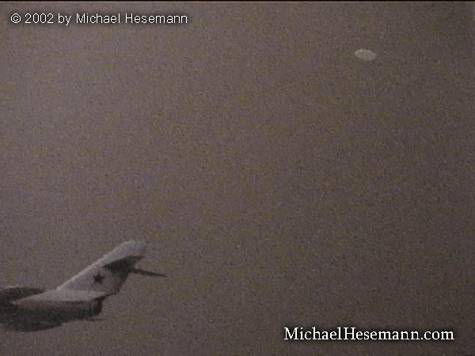
description:
UFO and a MIG-15 fighter over North Korea - allegedly filmed in 1952
Information by Michael Hesemann:
"STATEMENT OF (ON) UFO VIDEOS:
My grandfather dies (died) on ..., 2001. It was in Armenia in Yerevan. I was born in Yerevan. My grandfather work(ed) for the government and I always ask(ed) him all the time about his work because I admire(d) him and he would smile and tell me in Armenian, that it was not my business. He was not being mean, he would smile.
Every Sunday he have (had) friends over and he was very busy. I met some of his colleagues in the government, I never pay (paid) much attention to their names, I always remember first names, but my grandfather had many friends in the government. He did some secret work for them and the military.
My grandfather was (a) very good friend of Anastas Mikoyan (Politburo member under Josef Stalin, MH). They met when they were young boys. Mikoyan went to Politburo and my grandfather stay(ed) in Yerevan. Mikoyan would call when he need(ed) something from my grandfather.
When my grandfather die(d), I went (back) to Armenia after he died and I finish school for last year. Up in the top floor was (were) boxes of his stuff. There were many papers and files and some video tapes. I did not take time to read many of the papers but I make sure they were put in boxes for me to look at later.
I was interested in (the) videos because I could use the tapes for something else if they were not important. My grandfather record movies on TV and no one like(d) them but him.
I get (got) some of these tapes. They have movies on them, and then I find (found) one tape that have (has) military info on it in Armenian and I see these UFOs. This is military film of UFOs. There is a piece of paper that list(s) information about them, place and date, but I do not know which film is which. When you view them you can see which ones are which. I then go (went) into (a) store later (back in the Czech Republic) to buy food at (the city of) Dejvicka and I see your magazine 2000 and I see (read) about the UFOs.
Then I find (found) your web site and I see (saw) your photo with (the) Pope and I know (knew) you are the right person to sell this to. I only want (the) money to help my mother, which is my family. My father I do not know, he left us years ago when I was a small boy. I was close to my grandfather and he give (left) me everything according to the attorney in his will. I will go back (to Armenia) and (will) go through his documents and learn more about this. I want to be careful so I do not get found out (caught).
I know my grandfather would not talk about the UFOs seen in Armenia in the early 1980s. I was young and do not remember much, but I remember police coming to talk to grandfather about them so this is why I think he was involved. Why would the police come to him if this was not true. I could hear them talk about it, about (a) large object seen near our mountain, Ararat.
I later ask(ed) grandfather and he said he could not talk about it.
Now I have this video I want to learn more and will when I go back to Armenia and also in (the) army I can (will) ask quiet(ly) and try to find out things.
T."

Over North Korea
1952
description:
UFO and a MIG-15 fighter over North Korea - allegedly filmed in 1952
Information by Michael Hesemann:
"STATEMENT OF (ON) UFO VIDEOS:
My grandfather dies (died) on ..., 2001. It was in Armenia in Yerevan. I was born in Yerevan. My grandfather work(ed) for the government and I always ask(ed) him all the time about his work because I admire(d) him and he would smile and tell me in Armenian, that it was not my business. He was not being mean, he would smile.
Every Sunday he have (had) friends over and he was very busy. I met some of his colleagues in the government, I never pay (paid) much attention to their names, I always remember first names, but my grandfather had many friends in the government. He did some secret work for them and the military.
My grandfather was (a) very good friend of Anastas Mikoyan (Politburo member under Josef Stalin, MH). They met when they were young boys. Mikoyan went to Politburo and my grandfather stay(ed) in Yerevan. Mikoyan would call when he need(ed) something from my grandfather.
When my grandfather die(d), I went (back) to Armenia after he died and I finish school for last year. Up in the top floor was (were) boxes of his stuff. There were many papers and files and some video tapes. I did not take time to read many of the papers but I make sure they were put in boxes for me to look at later.
I was interested in (the) videos because I could use the tapes for something else if they were not important. My grandfather record movies on TV and no one like(d) them but him.
I get (got) some of these tapes. They have movies on them, and then I find (found) one tape that have (has) military info on it in Armenian and I see these UFOs. This is military film of UFOs. There is a piece of paper that list(s) information about them, place and date, but I do not know which film is which. When you view them you can see which ones are which. I then go (went) into (a) store later (back in the Czech Republic) to buy food at (the city of) Dejvicka and I see your magazine 2000 and I see (read) about the UFOs.
Then I find (found) your web site and I see (saw) your photo with (the) Pope and I know (knew) you are the right person to sell this to. I only want (the) money to help my mother, which is my family. My father I do not know, he left us years ago when I was a small boy. I was close to my grandfather and he give (left) me everything according to the attorney in his will. I will go back (to Armenia) and (will) go through his documents and learn more about this. I want to be careful so I do not get found out (caught).
I know my grandfather would not talk about the UFOs seen in Armenia in the early 1980s. I was young and do not remember much, but I remember police coming to talk to grandfather about them so this is why I think he was involved. Why would the police come to him if this was not true. I could hear them talk about it, about (a) large object seen near our mountain, Ararat.
I later ask(ed) grandfather and he said he could not talk about it.
Now I have this video I want to learn more and will when I go back to Armenia and also in (the) army I can (will) ask quiet(ly) and try to find out things.
T."

