UFO Photographs Slideshow

NAVIGATION MENU Photo 18 of 176 | FIRST | PREVIOUS | NEXT | LAST

Oregon Coast
August 10, 2002
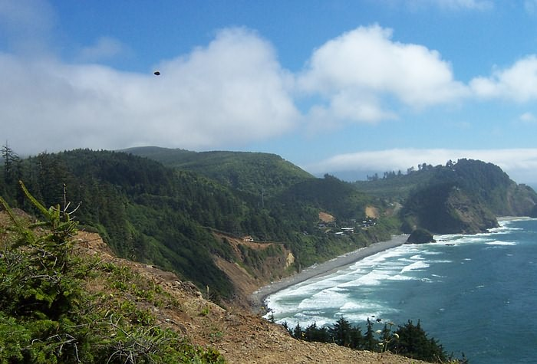
description:
A family from Monmouth visiting the coast recently was sight seeing at Cape Meares, a beautiful scenic area over looking the ocean. The father had taken a lot of photographs that day with his Kodak digital camera.
...a panoramic ocean-beach sequence shot from the cliff on the southwest side of the park, by the giant Sitka Spruce, was one of those photos. When he got home and downloaded his pictures he was excited to see the photos because of the wonderful scenery he had captured with his camera.
The photographer writes...
"There was one photo that appeared flawed? I examined it closer, and the first question I asked myself is "what in the world is this?" The longer I have looked at this the more questions I have? I'm sending you an unaltered copy of the photo I took, I'm also including a zoomed in photo of the object in the original photo."
An investigation was opened and the photographer was interviewed over the phone by assistant director Eric Byler of OUFOR. That call revealed there were 5 people at the cliff side where the photo was taken...his wife, himself, his two kids ages 10 and 14 and a retired park ranger sitting behind them on a bench. His wife and two kids were standing to the right of him as he took a series of photos, taken 1 to 2 seconds apart, from right to left, the photo in question being the last one taken. All five photos were examined and indeed the positioning of the clouds in each picture does indicate that the photos were taken one right after the other from right to left with the object appearing in the last photo.
Directly after the last photo was snapped, the gentleman sitting at the bench striked up a conversation with the family, pulling their attention away from the view for a while before heading back down the trail. The photographer reports there is no trail to the left, in the direction of the object, by which someone could be standing...in fact to the left there is more drop off cliff area and that the spot where they stood was more of a kind of view point. It appears as if the object in the picture is over an area where no one could be hiking due to the elevation of the slope and brush. Byler inquired about the possibility of the kids throwing rocks and he dismissed it as he would not have allowed them to do so as he keeps pretty tight reins on his kids. He also noted not remembering any rocks of any noticeable size worth throwing up there anyway.
A great deal of e-mail conversation and analysis amongst OUFORs Byler, photo analyst Bruce Maccabee and MUFON photo expert Jeff Sainio took place during the days of October 8th through the 17th but no conclusive opinion could be rendered as to whether the object was in fact present in the space it appears or if it was a product of camera malfunction. Here is some of the analysis from those exercises.
On the issue of distance, if in fact the image was present in the space it appears, Sainio notes that the image in the photograph measured an RGB brightness (on a 0-255 scale) of 18/29/57; the blue being brightest which is typical in a mostly blue sky. Nearby branches measured 0/2/0 in spots, so 'green' in shade does measure dark. The trees 'below' (in the picture) near the shore waves are about as bright as the unknown object (21/28/20, brightest in green as expected), thus suggesting the object is about as distant as those beach front trees. This suggests the image in the photograph (if real, which it appears to be) is as far or closer than the nearby trees at the bottom of the hill.
However, there was an issue of a lack of brightness of the image or reflective areas at the outer edges which should have been present under the assumed daylight conditions present in the photo. Further analysis was offered by Bruce Maccabee.
Bruce adds that the image is dark, but not as dark as the shadows in the nearby bushes at the lower left. Converting the picture to grey scale (removing color) , the darkest area he found was in the nearby bushes. It was 1 unit (there were a couple of zeroes, but there is never really zero; the digitization assigns zero to any level below some minimum). The darkest pixel on the unknown (at the left, lower) was 5 units. By way of comparison, the windows on the distant house gave 30 and 32 units. The intrinsic brightness of the windows should be near zero because light goes in and very little comes back out (black hole). There is a small fraction (less than 8% ) of the incident light reflected at the window surface. This reflection toward the camera has to obey the equal angle rule (angle of reflection = angle of incidence). Imagining a projection from the camera to a window and following the reflection one sees that light from the ground and perhaps some from the water would be reflected by the window toward the camera, but only about 8% of it. So, for practical purposes the darkest window pixel would have a brightness of near zero it if were nearby. We can attribute most of the brightness reading of 30 units, say 29 units, to atmospheric light (the "glow" of the atmosphere under solar illumination). That is the optical pathway from the object (window) to the camera which "collects" (scattered) light over the whole distance. The light added per unit length is about constant, so the longer the path, the greater the increase in brightness due to the atmosphere. This increase in 29 units (assumed) due to the fact that the atmosphere corresponds to a certain distance to the window and also to the amount of light scattering, the "quantity of haze," per unit length.
If we assume that the darkest part of the unknown had an intrinsic brightness of zero, such as if it were painted black, then its brightness reading of only 5 would mean it was much closer than the window, so that the atmospheric path between the camera and the object would be much shorter. A sample calculation can show just how much closer the unknown would be than the window. This is based on contrast reduction:
Cr = Co e^(-vr) where Cr =constrast at range r = |Br - Bb|/Bb , Co = contrast at range 0 = |Bo - Bb|/Bb, Br = brightness at range r, Bo = brightness at range 0 (intrinsic brightness), Bb = background brightness, v = attenuation coefficient and r = range. For the window Bruce is assuming that the intrinsic brightness is only 1 unit (due to reflected light from the glass). The background brightness, Bb, of the window varies from 50 to 120 units depending upon the bare dirt or the grass and trees. Most of the area around the house window (except the small white area of the house itself) is dark trees. Hence he is assuming a useable Bb for the house is about 80 units. He doesn't know how far away the house is, but is assuming 1 mile. Then we can get -vr = ln(Cr/Co) or v = attenuation coefficient. = - (1/r)ln(Cr/Co) where Cr/Co = |Br - Bb|/|Bo - Bb| = |30 - 80|/|1 - 80| = 0.63, so v = -(1/ 1mile) ln(.63) = 0.457/mile. [According to the definition of "visibility", R, the range at which one should barely be able to see something in the distance if it is a dark object, R = 3.9/v. Hence in this case R = 3.9/.457 = 8.5 miles. This is a condition of "haze"... which certainly is consistent with the images of haze or thin fog over the water and to some extent over the land.
Having found v from the photographic "data" (assumed relative brightnesses, assumed intrinsic brightness and assumed distance) we can use this v to estimate the distance to the "UFO" if it were instrinsically dark.
Assume Bo for the "UFO" was 0 units. IN the sky its darkest pixel is 5 units and the background sky has a relative brightness of about 170 units. Hence Cr/Co = |5 - 170|/|0 - 170| = 0.97 so -(0.457/miles) r = ln(.97) = -0.030. Hence r = .03/.457 = 0.066 miles or about 350 ft!!!
Although this distance may not be correct, it would seem to be in the ballpark. But at least the calculation shows the following: IF you assume it was a real object out there , AND noting that the image is very dark against the sky, IF you assume it was "wearing basic black" (at least on the portions visible to the camera) and IF you assume it wasn't illuminated by direct sunlight, THEN its "extreme contrast" with the background sky must mean it was close to the camera so there was not enough distance for atmospheric light to "build up" along the optical path.
Bruce writes..."NOTE: as I did the above calculations I did not know beforehand what the result was going to be. I simply applied equations similar to those used in the Trent case analysis. You will note that the attenuation coefficient I calculated depends directly upon the assumed distance to the house. If the house were 2 miles away the attenuation coefficint would have to be large...the visibility range would be twice as large and the calculated distance to the "UFO" would be twice as large...but still quite close!
From this calculated distance it would be possible calculate the size (projected perpendicular to the line of sight) if I knew the focal length and the format, i.e., is this equivalent to a 35 mm format with a 50 mm lens? For example, the "UFO" image is about 20 pixels long out of about 1800 across the format. If this is equivalent to 35 mm across and the focal length were 50 mm, then the image length is (20/1800) x 35 mm = 0.39 mm and the angular size is 0.39/50 = 0.0078 radians. The angular size projects out to a distance of 350 ft as 350 x 0.0078 = 2.7 ft.
When all the analysis was done, all parties agreed that...
a) We could not say for sure whether the image was in fact outside the camera, as some of the findings questioned whether or not the image could be a product of camera malfunction. While some of the evidence pointed in that direction, other evidence pointed away from it.
b) If in fact the image in picture 5 were outside the camera and suspended out over the cliff as it appears to be, it is an unknown, but probably not a large one....
Note...unknown does not necessarily mean it was a "spaceship"/TRUFO/AFC (AFC = alien flying craft)
Oregon UFO Research is very grateful for the time and efforts of Dr. Bruce Maccabee and Jeff Sainio. They are considered the best in their field of study and their work is appreciated.
Eric Byler - Assistant Director, Oregon UFO Research.
Source: Oregon UFO Research
Original source webpage / article

FAIR USE NOTICE: This page contains copyrighted material the use of which has not been specifically authorized by the copyright owner. This website distributes this material without profit to those who have expressed a prior interest in receiving the included information for research and educational purposes. We believe this constitutes a fair use of any such copyrighted material as provided for in 17 U.S.C § 107.

