Orbit around Earth, NASA Space Shuttle Mission STS-51a
September, 1993
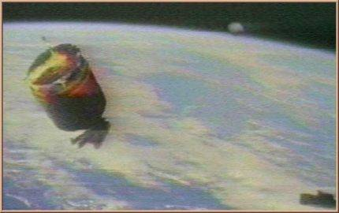
description:
In the approach phase to WESTAR VI, the video camera on board the Space Shuttle Discovery "STS-51a" manages to film a light metal coloured sphere which comes from the left and then disappears to the rigth. On the background we can see the earth.
Source: NASA (reprinted on UFO Area)
Original source webpage / article

