Ondrejov Observatory, Czechoslovakia
1988
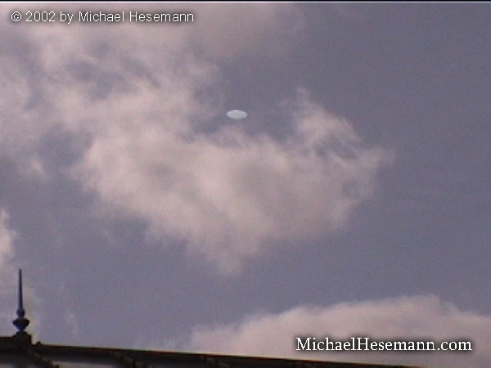
description:
UFO over the Ondrejov Observatory, Czechoslovakia, August 15, 1988
Information by Michael Hesemann:
"STATEMENT OF (ON) UFO VIDEOS:
My grandfather dies (died) on ..., 2001. It was in Armenia in Yerevan. I was born in Yerevan. My grandfather work(ed) for the government and I always ask(ed) him all the time about his work because I admire(d) him and he would smile and tell me in Armenian, that it was not my business. He was not being mean, he would smile.
Every Sunday he have (had) friends over and he was very busy. I met some of his colleagues in the government, I never pay (paid) much attention to their names, I always remember first names, but my grandfather had many friends in the government. He did some secret work for them and the military.
My grandfather was (a) very good friend of Anastas Mikoyan (Politburo member under Josef Stalin, MH). They met when they were young boys. Mikoyan went to Politburo and my grandfather stay(ed) in Yerevan. Mikoyan would call when he need(ed) something from my grandfather.
When my grandfather die(d), I went (back) to Armenia after he died and I finish school for last year. Up in the top floor was (were) boxes of his stuff. There were many papers and files and some video tapes. I did not take time to read many of the papers but I make sure they were put in boxes for me to look at later.
I was interested in (the) videos because I could use the tapes for something else if they were not important. My grandfather record movies on TV and no one like(d) them but him.
I get (got) some of these tapes. They have movies on them, and then I find (found) one tape that have (has) military info on it in Armenian and I see these UFOs. This is military film of UFOs. There is a piece of paper that list(s) information about them, place and date, but I do not know which film is which. When you view them you can see which ones are which. I then go (went) into (a) store later (back in the Czech Republic) to buy food at (the city of) Dejvicka and I see your magazine 2000 and I see (read) about the UFOs.
Then I find (found) your web site and I see (saw) your photo with (the) Pope and I know (knew) you are the right person to sell this to. I only want (the) money to help my mother, which is my family. My father I do not know, he left us years ago when I was a small boy. I was close to my grandfather and he give (left) me everything according to the attorney in his will. I will go back (to Armenia) and (will) go through his documents and learn more about this. I want to be careful so I do not get found out (caught).
I know my grandfather would not talk about the UFOs seen in Armenia in the early 1980s. I was young and do not remember much, but I remember police coming to talk to grandfather about them so this is why I think he was involved. Why would the police come to him if this was not true. I could hear them talk about it, about (a) large object seen near our mountain, Ararat.
I later ask(ed) grandfather and he said he could not talk about it.
Now I have this video I want to learn more and will when I go back to Armenia and also in (the) army I can (will) ask quiet(ly) and try to find out things.
T."
-----------------------
According to T. the footage was taken in the following years:
North Korea 1952
Krakov, Poland, July 7, 1986
Helsinki, Finland, September 12, 1996
Ondrey´s Observatory, CSSR, August 15, 199
Vilnius, Lithuania July 18, 1976
He also mentioned footage from
Romania
a Soviet Airbase
German WW 2 Footage
To quote from his e-mail, the footage shows "a UFO flying over a MIG in Korea. The plane adjust(s) position to get better see (sight) at (of the) UFO. (The) film was taken from (an)other MIG. Another film show(s) a UFO flying over (an) American plane at a base in the USA. It is a clear disk. Another one show(s) a UFO over (a) Romanian plane. Another show(s) (a) UFO over (a) MIG on the air base and another show(s) a UFO over a MIG sitting on (the) runway only a few years ago. Another shows a UFO taken at Ondrejov Observatory in Czech Republic (sic!). This is footage of (a) famous UFO story. There is another UFO (, a) big disk in Lithuania and also at night with night camera that show(s a) big disk and also (a film) from World War II that show(s a) disk over (an) airplane from (a) German base. It is clear(ly) a disk. These were (the) best movie(s) from KGB agents who collect(ed) information and even steal (stole) camera(s) if they need to."
IF T.´s story is true, we can suspect the existence of a kind of Soviet MJ12 which ordered the collection of this exciting material. In one of his e-mails, dated February 22, 2002, he mentioned the fact that Mikoyan´s brother "create(d) the MIG and it was under this program that they design or try to make aircraft that was (were) copy (copies) of UFO(s) that was (were) reported. They also study reports and yes, as you know (,) there was a secret group."
Do we indeed face a major breakthrough by this unexpected release of unique, formerly Top Secret UFO footage from the archives of the KGB? Indeed, if T´s grandfather was indeed a member of the Soviet intelligence community or nomenclatura, we have to assume that he asked his former comrades for a video collection of some of the best UFO footage from their archives because he was personally interested in the subject. During the breakdown of the Soviet Union, followed by the independence of Armenia (and with it the end of the control by Moscow), this is very well possible. In these times, personal friendships and connections were more important than old orders and classifications.
Therefore it is very well possible that T´s story is true just the way he told it. In the investigation of this case we have to consider that the footage was most probably originally shot on 16 or 35 mm and later -during the 1990ies- copied on Video. On most of the seven films I received, the camera is stable, seems to be fixed, indeed indicating surveillance- or guncameras. On the other hand, a suspicious element in the lack of camera movement is that it would make it easier to copy "artificial" (computer-generated) UFOs into pre-existing footage. But then remains the question how a hoaxer would obtain raw footage from airborne and landed MIGs on Soviet Air Force Bases which, without the UFOs, make no sense at all.
Source: Michael Hesemann
Original

