NAVIGATION MENU Photo 70 of 176 | FIRST | PREVIOUS | NEXT | LAST

Ondrejov Observatory, Czechoslovakia
1988
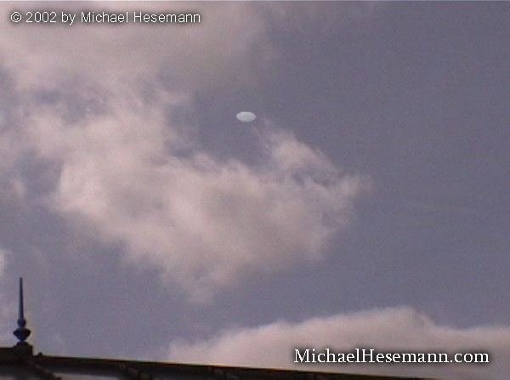
description:
UFO over the Ondrejov Observatory, Czechoslovakia, August 15, 1988

