Ocotlan, Jalisco, Mexico
April, 1993
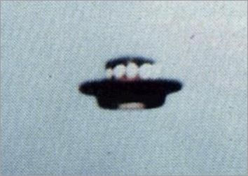
description:
Source:
Original source webpage / article

