Norway
July, 1957
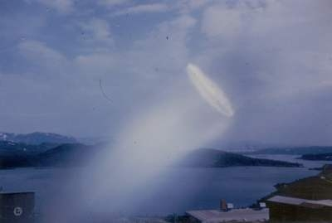
description:
UFOs at Close Sight (Patrick Gross)
From Project Blue Book files:

