NAVIGATION MENU Photo 17 of 176
FIRST | PREVIOUS | NEXT | LAST

Nijverdal, the Netherlands
2003
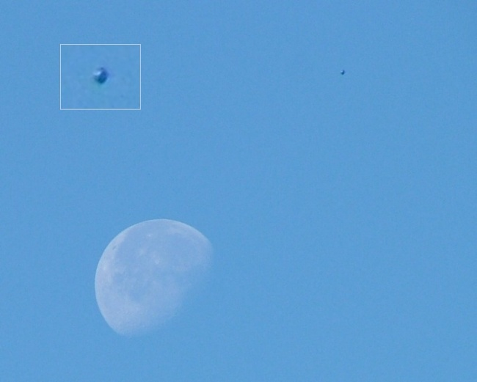
description:
A pic from Manipular Yet (nick name) from the Netherlands.
First published: UFOPlaza.nl
Submitted by Jan Blei, Columnist, the Netherlands
Source: UFOPlaza.nl (Submitted to UFO Evidence by Jan Blei)
Original source webpage / article

FAIR USE NOTICE: This page contains copyrighted material the use of which has not been specifically authorized by the copyright owner. This website distributes this material without profit to those who have expressed a prior interest in receiving the included information for research and educational purposes. We believe this constitutes a fair use of any such copyrighted material as provided for in 17 U.S.C § 107.

