New York, New York
1955
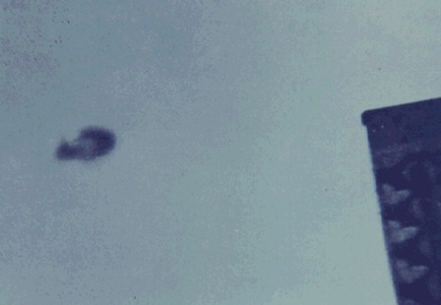
description:
Source:
Original source webpage / article

