NAVIGATION MENU Photo 10 of 176 | FIRST | PREVIOUS | NEXT | LAST

Netherlands
May 17, 2003
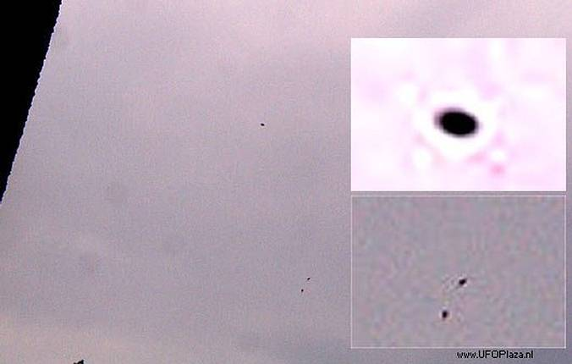
description:
AMERSFOORT -- An extraordinary UFO sighting was reported on May 17, 2003, when multiple witnesses saw some strange flying objects. A 36-year-old limousine driver, took some pictures with his HP 620 digital camera. Around 13:45 he took notice of a large weird shaped object in the sky with two smaller objects beneath it. The smaller objects seemed to be under intelligent control by the larger object in some way. The object appeared to be round shaped and reasonably large. The distance between the witness and the UFOs was about 350 meters at 300-meter altitude. The strange objects were gray-black and didn't make any noise. They moved at a variable speed, about 30 km/h average, at first south, and then north. After ten minutes the UFOs disappeared over the horizon.
The witness took three pictures of the strange flying objects that showed twenty perfectly round orbs that were not noticed by the witness during the sighting. Three orbs formed a triangular formation. Experts were contacted and couldn't explain the phenomena that was displayed.
Source: UFO Casebook / UFOPlaza.nl - Dutch UFO Disclosure
Original source webpage / article

FAIR USE NOTICE: This page contains copyrighted material the use of which has not been specifically authorized by the copyright owner. This website distributes this material without profit to those who have expressed a prior interest in receiving the included information for research and educational purposes. We believe this constitutes a fair use of any such copyrighted material as provided for in 17 U.S.C § 107.

